This is a sample application that displays baseball statistics.

The components are:

• a display file **BBALLDSP** with 2 record formats (Record 1 and Record 2).

• a group of logical files which select on Player Positions.

• an RPGLE program **PLAYERINFO**, that accepts one parameter.

• a CLLE driver program **DSPPLYRSP** that accepts two parameters and passes one of them to the RPG program. The second parameter is used to control overrides.

• a command **DSPPLYRS** that runs the CLLE program.

This sample is very similar to the programming tasks on the final exam.

## Physical File:

INPUT: BASEBALL12/AMERICANLG Record format: AMERICANLG

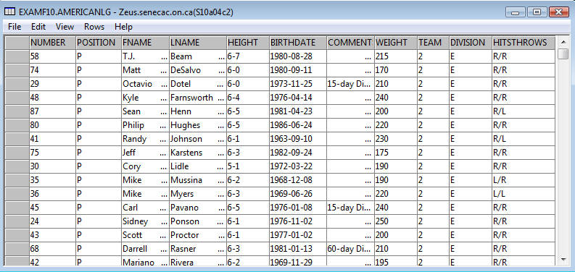

## Logical Files (used in this application):

**ALLPLAYERS.LF**

.....A..........T.Name++++++................Functions+++++++++++++++++++++++++++Comments+

A R AMERICANLG PFILE(BASEBALL12/AMERICANLG)

A K LNAME

A K FNAME

**PITCHERS.LF**

.....A..........T.Name++++++................Functions+++++++++++++++++++++++++++Comments+

A R AMERICANLG PFILE(BASEBALL12/AMERICANLG)

A K LNAME

A K FNAME

A S POSITION COMP(EQ 'P')

**CATCHERS.LF**

.....A..........T.Name++++++................Functions+++++++++++++++++++++++++++Comments+

A R AMERICANLG PFILE(BASEBALL12/AMERICANLG)

A K LNAME

A K FNAME

A S POSITION COMP(EQ 'C')

**OUTFIELD.LF**

.....A..........T.Name++++++................Functions+++++++++++++++++++++++++++Comments+

A R AMERICANLG PFILE(BASEBALL12/AMERICANLG)

A K LNAME

A K FNAME

A S POSITION COMP(EQ 'O')

**INFIELD.LF**

.....A..........T.Name++++++................Functions+++++++++++++++++++++++++++Comments+

A R AMERICANLG PFILE(BASEBALL12/AMERICANLG)

A K LNAME

A K FNAME

A S POSITION COMP(EQ 'I')

**As an alternate example (not used in this application) code the DDS for a logical file that would show only Bluejay pitchers called BLUEJAYP**

Produce the following logical file, BLUEJAYP using the appropriate method of either DDS code or SQL.

It is based on the AMERICANLG file in a library called BASEBALL12. The file data and field names show on page 1.

The logical file should select all Toronto Blue Jay Pitchers in last name order. The Blue Jay Team Number is 3 and the position code for a Pitcher is ‘P’.

If your choice is to use SQL – write the SQL code below the coding form:

T.Name++++++RLen++TDp.......Functions+++++++++++++++++++++++++++

_ __________ ________ _____________________________

_ __________ ________ _____________________________

_ __________ ________ _____________________________

_ __________ ________ _____________________________

_ __________ ________ _____________________________

_ __________ ________ _____________________________

_ __________ ________ _____________________________

**SAMPLE SCREEN SHOTS:**

OUTPUT: Display File - BBALLDSP

**CALL PLAYERINFO PARM('*YES')**

*YES indicates that all records will be processed but only the summary screen will be shown.

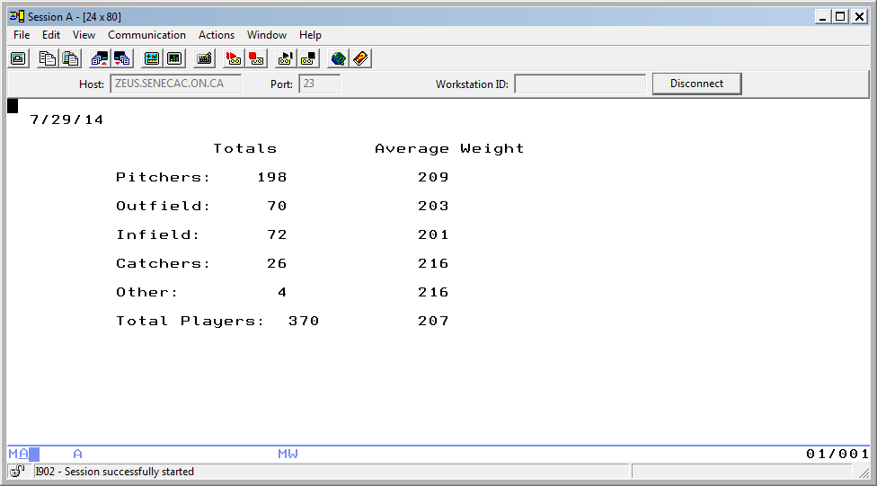

**RECORD 2 (SUMMARY SCREEN)**

**CALL PLAYERINFO PARM('*NO')**

*NO indicates that each record will be displayed and the user can press either the enter key to see the next record; the F3 key to see a summary screen for the records that have been viewed; or F8 to see a summary screen for the records that have been viewed plus the rest of the records in the file.

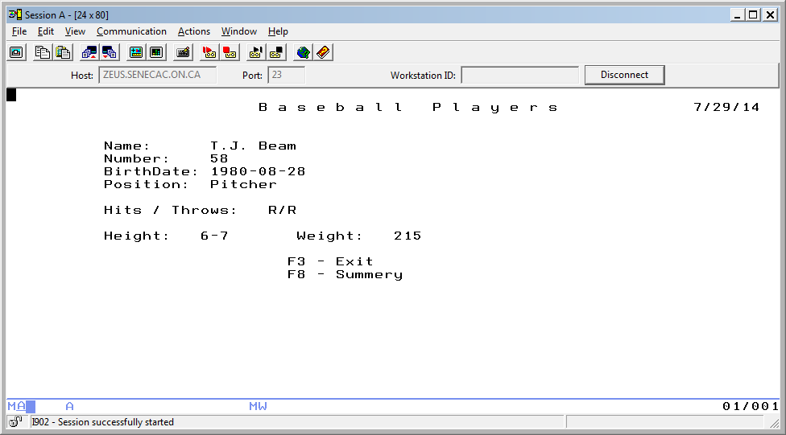

**RECORD 1 (First Detail Screen)**

ENTER pressed to see the next record

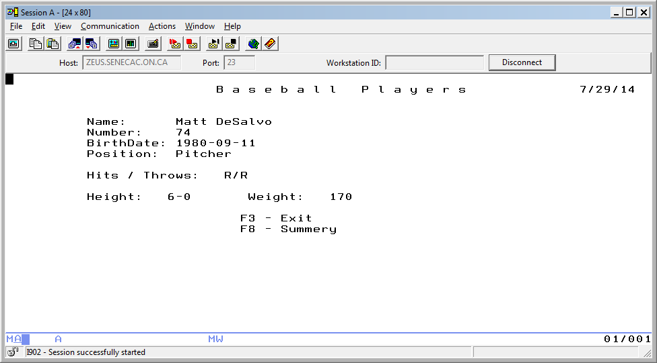

**RECORD 1 (Next Detail Screen)**

F3 pressed

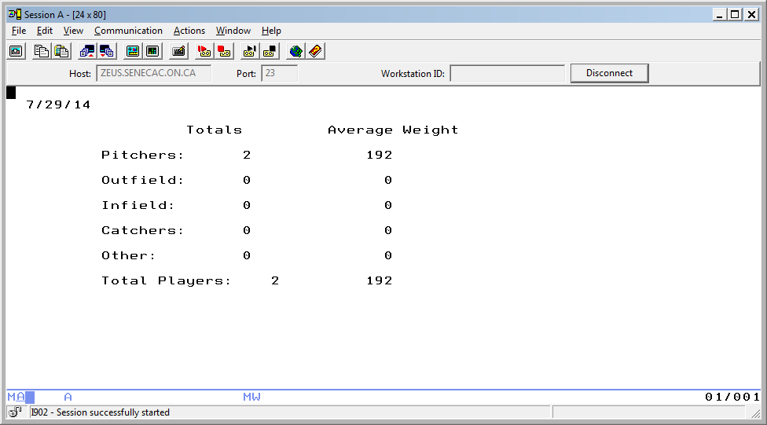

**RECORD 2**

OR

The first record was viewed, enter was pressed so the second record was viewed, then F8 was pressed and the rest of the records were processed but not individually displayed.

(after F8 pressed)

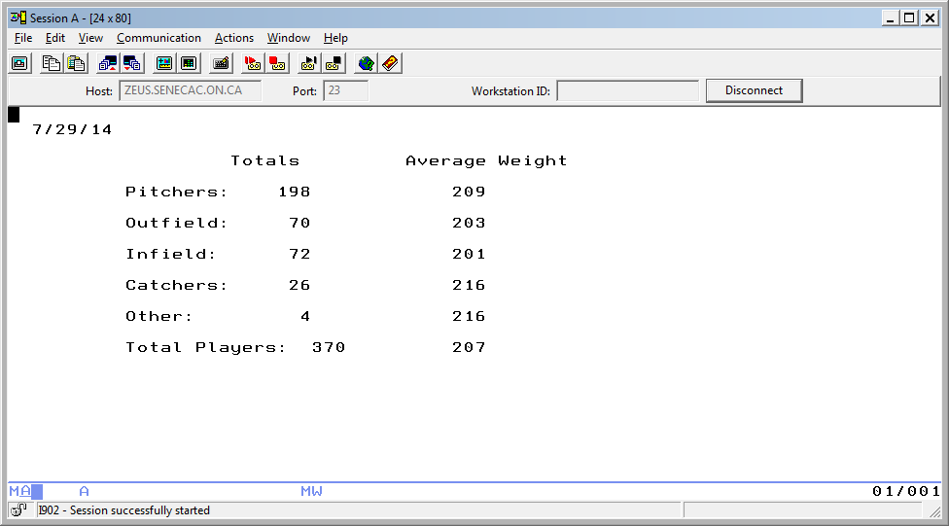

**RECORD 2**

**CALL** **DSPPLYRSP PARM('*PITCHERS' '*NO')**

Only pitchers show each time you press enter.

Pitchers show in alphabetical order by last name.

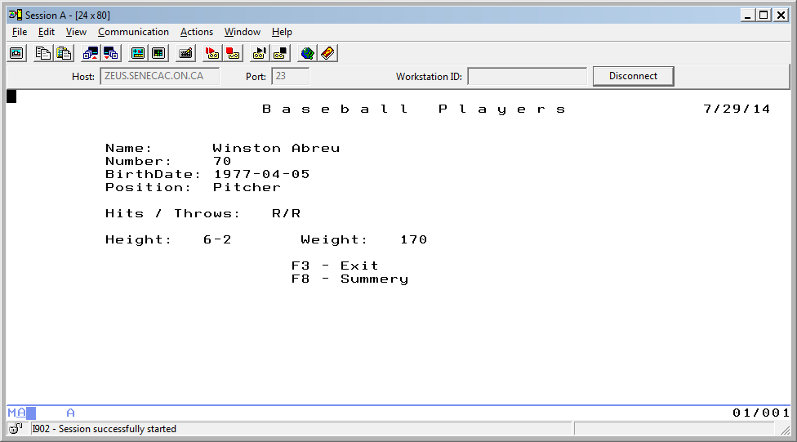

**RECORD 1 (First Detail Screen)**

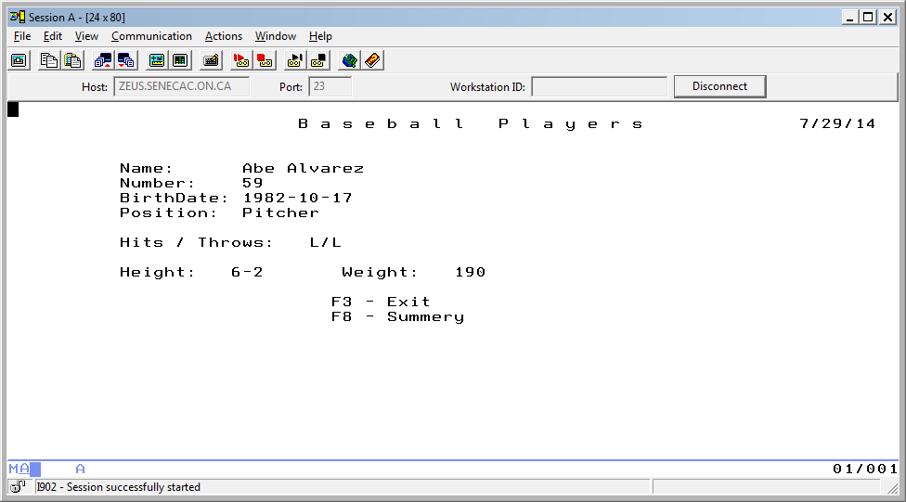

**RECORD 1 (Next Detail Screen)**

F3 would show summary info for the two pitchers, F8 would show summary info for all pitchers

F8 pressed

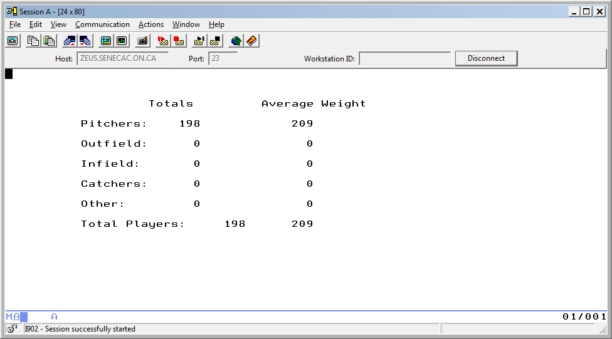

**RECORD 2**

**CALL** **DSPPLYRSP PARM('*CATCHERS' '*NO')**

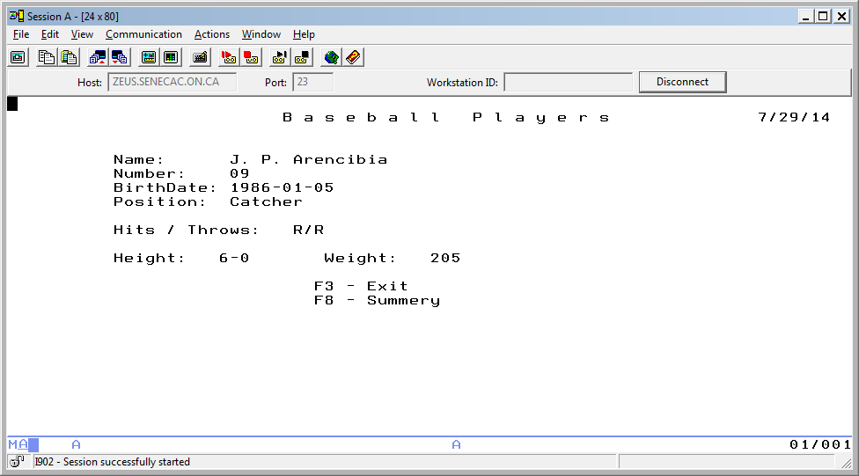

**RECORD 1**

**Display File: BBALLDSP**

A CF03(03 'EXIT')

A CF08(08 ' SUMMARY')

A **R RECORD1**

A HEIGHT R O 12 21REFFLD(AMERICANLG/HEIGHT +

A BASEBALL08/AMERICANLG)

A BIRTHDATE R O 7 22REFFLD(AMERICANLG/BIRTHDATE +

A BASEBALL08/AMERICANLG)

A WEIGHT R O 12 41REFFLD(AMERICANLG/WEIGHT +

A BASEBALL08/AMERICANLG)

A HITSTHROWSR O 10 28REFFLD(AMERICANLG/HITSTHROWS +

A BASEBALL08/AMERICANLG)

A NUMBER R O 6 22REFFLD(AMERICANLG/NUMBER +

A BASEBALL08/AMERICANLG)

A 14 30'F3 - Exit'

A 15 30'F8 - Summery'

A 12 11'Height:'

A 12 31'Weight:'

A 7 11'BirthDate:'

A 5 11'Name:'

A 10 11'Hits / Throws:'

A 8 11'Position:'

A FULLNAME 21 O 5 22

A PPOSITION 8 O 8 22

A 2 27'B a s e b a l l P l a y e r s'

A 2 71DATE

A EDTCDE(Y)

A 6 11'Number:'

A **R RECORD2**

A TOTALPITCH 3 0O 6 24EDTCDE(1)

A TOTALOUT 3 0O 8 24EDTCDE(1)

A TOTALIN 3 0O 10 24EDTCDE(1)

A TOTALCATCH 3 0O 12 24EDTCDE(1)

A 4 20'Totals'

A 8 11'Outfield:'

A 10 11'Infield:'

A 12 11'Catchers:'

A 14 11'Other:'

A TOTALOTHER 3 0O 14 24EDTCDE(1)

A 16 11'Total Players:'

A TOTALPLAY 3 0O 16 30EDTCDE(1)

A 4 35'Average Weight'

A 6 11'Pitchers:'

A AVGPITCH 3 0 6 39EDTCDE(1)

A AVGOUT 3 0 8 39EDTCDE(1)

A AVGIN 3 0 10 39EDTCDE(1)

A AVGCATCH 3 0 12 39EDTCDE(1)

A AVGOTHER 3 0 14 39EDTCDE(1)

A AVGPLAY 3 0 16 39EDTCDE(1)

**Processing:**

The screen dialog above indicates some of the processing with the enter key, F3 key and F8 key. When individual player records are being shown on the screen, the first and last names are stored in a calculated field for the full name.

The position of ‘P’ is converted to a calculated field containing ‘Pitcher’. ‘C’, ‘O’, ‘I’ are converted to ‘Catcher’, ‘Outfield’ and ‘Infield’.

Total counts are maintained for pitchers, catchers etc and average player weight for each position is determined.

File Type FT (IOUC) Record Length RL

File Designation FD (PSRTF) Record Address Type RAT (ADFKPDZ)

End of File EF Device (Printer,Disk,Workstn)

File Addition FA Keywords

File Format FF (FE)

Filename FT FD EF FA FF RL RAT Device Keywords

F________________ ___ ___ ___ ___ ___ ____ ___ ________________ _________________________

F________________ ___ ___ ___ ___ ___ ____ ___ ________________ _________________________

Declaration Type – Blank, DS, C, PI, PR, S, S/U – Blank, S, U

Keywords – ALIGN, DTAARA, EXPORT, EXTNAME(), EXTPGM(), FROMFILE(), OCCURS()

D* P A S S E D P A R A M E T E R (Only Summary Screen)

D* W O R K F I E L D S

Name S/U Declaration To/ Data Decimal Keywords

Type From Length Type Pos

D_________________ ___ ____ ___ ___ ___ ___ ____________________

D_________________ ___ ____ ___ ___ ___ ___ ____________________

D_________________ ___ ____ ___ ___ ___ ___ ____________________

D_________________ ___ ____ ___ ___ ___ ___ ____________________

D_________________ ___ ____ ___ ___ ___ ___ ____________________

D_________________ ___ ____ ___ ___ ___ ___ ____________________

D_________________ ___ ____ ___ ___ ___ ___ ____________________

D_________________ ___ ____ ___ ___ ___ ___ ____________________

D_________________ ___ ____ ___ ___ ___ ___ ____________________

D_________________ ___ ____ ___ ___ ___ ___ ____________________

D_________________ ___ ____ ___ ___ ___ ___ ____________________

**RPGLE program: PLAYERINFO**

/FREE

**CLLE Driver Program for RPGLE program**

PGM PARM(__________ __________)

DCL ___________ _______ __

DCL ___________ _______ __

ADDLIBLE ___________

_________ ___________

SELECT

WHEN (__________________) DO

______________________

______________________

ENDDO

WHEN

WHEN

WHEN

ENDSELECT

ENDPGM

***Command Programming***

Assuming the code has already been supplied in a source physical file called BBALLAPSRC for PLAYERINFO.RPGLE, DSPPLYRS.CMD, and DSPPLYRSP.CLLE: and DSPPLYRS has already been successfully compiled — provide the command being run to connect these two and the missing information for the prompts.

______________________________________ (command run)

Type choices, press Enter.

Command . . . . . . . . . . . . ___________ Name

Library . . . . . . . . . . . ___________ Name, *CURLIB

Program to process command . . . ___________ Name, *REXX

Library . . . . . . . . . . . ___________ Name, *LIBL, *CURLIB

Source file . . . . . . . . . . ___________ Name

Library . . . . . . . . . . . ___________ Name, *LIBL, *CURLIB

Source member . . . . . . . . . *CMD Name, *CMD

DSPBBLPLY (F4)

|  |
| --- |
| DISPLAY BASEBALL PLAYERS (DSPPLYRS)    Type choices, press Enter.    WHICH SET OF PLAYERS? . . . . . ___________ *ALL, *PITCHERS, *CATCHERS...  ONLY SHOW SUMMARY INFORMATION? *NO *YES, *NO      Bottom  F3=Exit F4=Prompt F5=Refresh F12=Cancel F13=How to use this display  F24=More keys  **Parameter PLAYERTYPE required.** |

The command entered below shows with keyword notation and the default value being overridden.

The user must indicate which set of players are to be reported on.

==> DSPPLYRS PLAYERTYPE(*PITCHERS) SUMMARY(*YES)

Using some or all of the following, provide the command source code for DSPPLYRS.CMD

CMD ‘XXXX‘,PARM,KWD(),MIN(),SPCVAL(),TYPE(),LEN(),RSTD(),VALUES(),QUAL(),PROMPT()

________________________________________________________________________________________

________________________________________________________________________________________

________________________________________________________________________________________

________________________________________________________________________________________

________________________________________________________________________________________

________________________________________________________________________________________

________________________________________________________________________________________

________________________________________________________________________________________

________________________________________________________________________________________

________________________________________________________________________________________

________________________________________________________________________________________

________________________________________________________________________________________

________________________________________________________________________________________

________________________________________________________________________________________

CL commands and Syntax:

|  |  |  |  |
| --- | --- | --- | --- |
| Command | Parameter keyword(s) | Command | Parameter keyword(s) |
| ADDLIBLE | LIB POSITION | RCVF | DEV RCDFMT OPNID WAIT |
| CALL | PGM PARM | RMVLIBLE | LIB |
| CALLPRC | PRC PARM RTNVAL | RTVJOBA | DATE USER |
| CHGCURLIB | CURLIB | RTVSYSVAL | SYSVAL RTNVAR |
| CHGLIBL | LIBL CURLIB | RTVUSRPRF | RTNUSRPRF TEXT MAXSTG STGUSED PWDEXPITV OUTQ OUTQLIB |
| CHGVAR | VAR VALUE | RUNQRY | QRY QRYFILE OUTTYPE  OUTFORM RCDSLT |
| DCL | VAR TYPE LEN VALUE | RVKOBJAUT | OBJ OBJTYPE ASPDEV  USER AUT AUTL |
| DCLF | FILE RCDFMT OPNID | SELECT |  |
| DO |  | SNDMSG | MSG TOUSR |
| DOFOR | VAR FROM TO BY | SNDUSRMSG | MSGRPY |
| DOUNTIL | COND | SELECT |  |
| DOWHILE | COND | SNDMSG | MSG TOUSR |
| DSPMSG |  | SNDPGMMSG | MSG |
| DSPSPLF | SPLNBR(*LAST) | SNDRCVF | DEV RCDFMT OPNID WAIT |
| EDTOBJAUT | OBJ OBJTYPE ASPDEV | SNDUSRMSG | MSG MSGID MSGF MSGDTA VALUES MSGTYPE  TOMSGQ TOUSR MSGRPY |
| EDTLIBL |  | WHEN | COND THEN |
| ELSE | CMD | WRKOUTQ | OUTQ |
| ENDDO |  | WRKSPLF |  |
| ENDPGM |  |  |  |
| ENDSELECT |  |  |  |
| GOTO | CMDLBL | String Handling |  |
| GRTOBJAUT | OBJ OBJTYPE ASPDEV  USER AUT AUTL REFOBJ REFOBJTYPE REFASPDEV  REPLACE | %SST(&FIELDA offset length)  &STRINGA *CAT &STRINGB  &STRINGA *BCAT &STRINGB  &STRINGA *TCAT &STRINGB |  |
| IF | COND THEN | Indicators | &IN03 |
| MONMSG | MSGID CMPDTA EXEC |  |  |
| PGM | PARM |  |  |
| OTHERWISE | CMD |  |  |
| OVRDBF | FILE TOFILE LVLCHK |  |  |
| OVRPRTF | FILE SPLFNAME |  |  |

**RPG Verbs, Functions and Special Values**

|  |  |  |  |  |  |
| --- | --- | --- | --- | --- | --- |
| RPG | Attribute | RPG | Attribute | RPG | Attribute |
| %EOF | File Name | *ENTRY |  | RENAME(recordformat:newformat) | |
| DOU | Condition | PLIST |  |  |  |
| DOW | Condition | PARM |  | %TRIMR(fieldname) |  |
| ENDDO |  | *IN03 |  |  |  |
| ENDIF |  | EXSR |  |  |  |
| ENDSL |  | BEGSR |  |  |  |
| EXFMT | Record name | ENDSR |  |  |  |
| IF | Condition | *INLR = *ON |  |  |  |
| OTHER |  | OFLIND(*INOF) |  |  |  |
| READ | File Name | WRITE | Record name |  |  |
| SELECT |  | WHEN | Condition |  |  |